SST TRACK JACKET
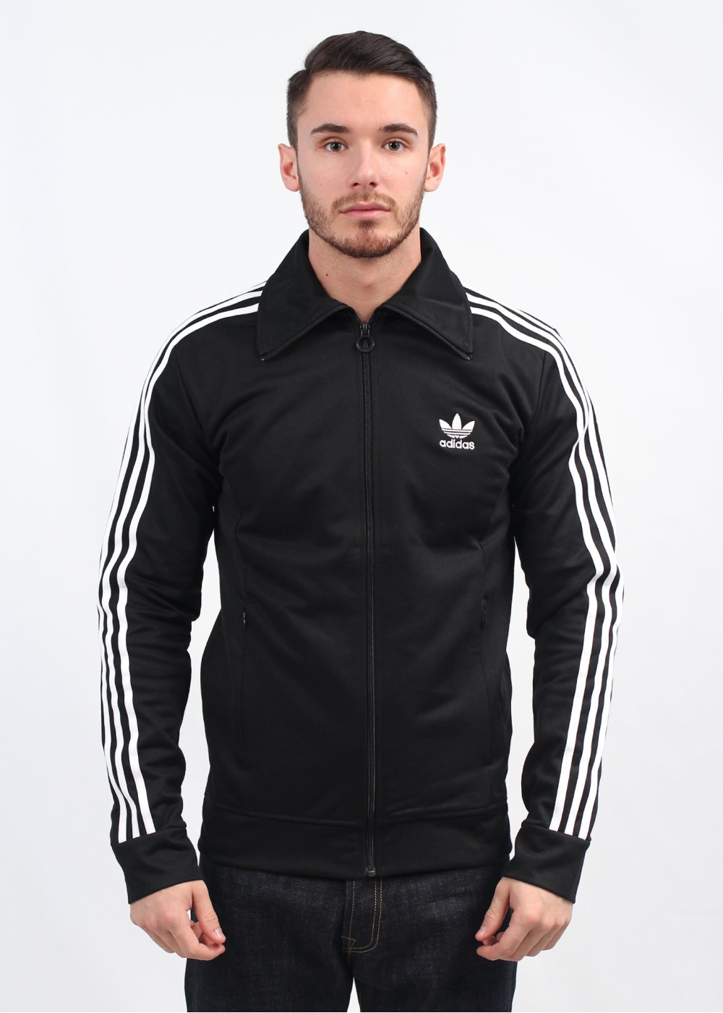
$75

- Regular fit is not tight and not loose, the perfect in-between fit
- Ribbed collar
- Long sleeves
- 70% recycled polyester / 30% cotton interlock
- This jacket is made with recycled polyester to save resources and decrease emissions; We partner with the Better Cotton Initiative to improve cotton farming globally
- Side zip pockets; Full two-way zip

